

**Capstone Project Report**

**Report 1 – Project Introduction**

– Hanoi, August 2019 –

**Table of Contents**

I. Project Report 3

1. Status Report 3

2. Team Involvements 3

3. Issues/Suggestions 3

II. Project Introduction 4

1. Overview 4

1.1 Project Information 4

1.2 Project Team 4

2. Product Background 4

3. Existing Systems 4

3.1 System name1 4

3.2 System name2 4

4. Business Opportunity 5

5. Software Product Vision 5

6. Project Scope & Limitations 5

6.1 Major Features 5

6.2 Limitations & Exclusions 6

# I. Project Report

## 1. Status Report

|  |  |  |  |
| --- | --- | --- | --- |
| **#** | **Work Item** | **Status** | **Notes (Work Item in Details)** |
| 1 |  | Pending |  |
| 2 |  | In Progress |  |
| 3 |  | Completed |  |

## 2. Team Involvements

|  |  |  |  |
| --- | --- | --- | --- |
| **#** | **Task** | **Member** | **Notes (Task Details, etc.)** |
| 1 |  | KienNT |  |
| 2 |  | TuanTV |  |
| 3 |  | AnhLM |  |

## 3. Issues/Suggestions

|  |  |  |  |
| --- | --- | --- | --- |
| **#** | **Issue** | **Status** | **Notes (Solution, Suggestion, etc.)** |
| 1 |  | Pending |  |
| 2 |  | In Progress |  |
| 3 |  | Completed |  |

# II. Project Introduction

## 1. Overview

### 1.1 Project Information

* Project Name: Application for studying Vietnamese for foreigners
* Project code: FA20SE39
* Group name:
* Software type: Mobile App

### 1.2 Project Team

#### a. Supervisor

|  |  |  |  |
| --- | --- | --- | --- |
| **Full Name** | **Email** | **Phone Number** | **Title** |
| Lại Đức Hùng | HungLD5@fe.edu.vn |  | Lecturer |
| Nguyễn Thế Hoàng | HoangNT20@fe.edu.vn | 0986628525 | Lecturer |

#### b. Team Members

|  |  |  |  |
| --- | --- | --- | --- |
| **Full Name** | **Email** | **Mobile** | **Role** |
| Hồ Xuân Cường | cuonghxse63139@fpt.edu.vn | 0337239966 | Leader |
| Đặng Mạnh Tường | tuongdmse62978@fpt.ed.vn | 0966422659 | Member |
| Nguyễn Duy Anh | anhndse62808@fpt.ed.vn | 0336125588 | Member |
| Hồ Quang Bảo | baohqse63353@fpt.ed.vn | 0932002321 | Member |

## 2. Product Background

In this document, we introduce an application for studying Vietnamese for foreigners. We build an application that helps people learn Vietnamese easier. You can learn vocabulary, communicate through the curriculum by practicing speaking, writing, listening, and quizzing. You can play some games to increase your vocabulary. You also can use a camera to translate the picture.

## 3. Existing Systems

### 3.1 Drops

Description: Drops helps user learns new vocabulary through fun, fast-paced games with simple mnemonic images

Link: https://languagedrops.com

System actor: learner

Features:

1. Learn vocabulary by topic
2. Learn by picture and audio
3. Notification remind learning

Advantage:

* Interesting way of learning
* Friendly user interface

Disadvantage:

* Can only learn vocabulary
* Don’t have a clear curriculum

## 4. Business Opportunity

## Today, many people want to come to Vietnam for many reasons such as traveling, working, living…. It is difficult for foreigners to communicate with Vietnamese people. It takes a lot of time to learn at teaching centers. Foreigners also do not know where to learn Vietnamese.

## 5. Software Product Vision

For foreign people, who want to learn Vietnamese quickly and easily. The Application for studying Vietnamese for foreigners is a mobile app that allows foreign people to learn Vietnamese anytime and anywhere as long as there is internet available. Unlike other apps on the market, our products focus on the most effective and enjoyable way to learn Vietnamese.

## 6. Project Scope & Limitations

This is a Vietnamese learning application for foreigners. In this application help learn to study through the standard curriculum, it also has practice listening, writing, speaking feature. After each lesson, it also has a quiz to test learn knowledge about Vietnamese.

This application does not support multi-language, it just supports Vietnamese and English

### 6.1 Major Features

FE-01: Login

FE-02: Signup

FE-03: Get Profile

FE-04: Logout

FE-05: Pick Level

FE-06: Play game

FE-07: Study Lesson

FE-08: Learn vocabulary

FE-09: Learn Conversation

FE-10: Take the quiz

FE-11: Create a new lesson

FE-12: Create vocabulary

FE- 13: Create a conversation

FE-14: Create lesson by available template

FE-15: Update Lesson

FE-16: Update Vocabulary

FE-17: Update Conversation

FE-18: Create Post

FE-19: Edit Post

FE-20: Get Post

FE-21: Search Post

FE-22: Comment

FE-23: Remove own comment

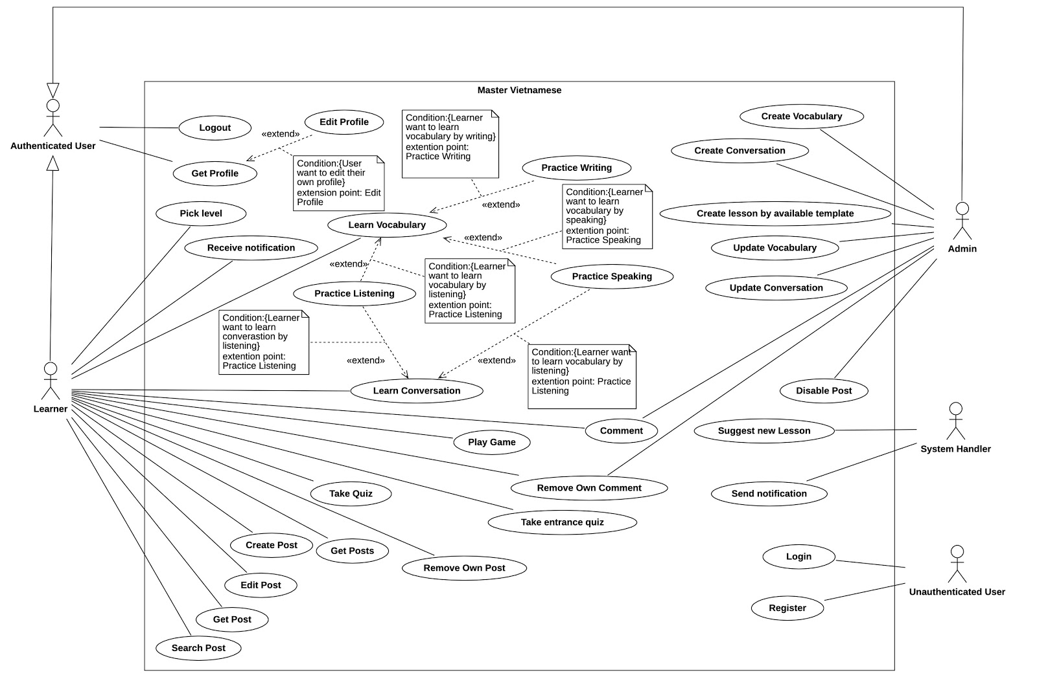

Figure 1-Use case diagram

### 6.2 Limitations & Exclusions

LI-01: Application-only support Vietnamese and English.

LI-02: Must always have internet connection to use the application.